**A Mini Project Report on**

**VOICE CONTROLLED SMART CAR**

**Submitted to**

**Jawaharlal Nehru Technological University,Hyderabad**

***in partial fulfillment of requirements for the award of the degree of***

**BACHELOR OF TECHNOLOGY**

**In**

**COMPUTER SCIENCE AND ENGINEERING (AI&ML)**

**By**

**GAURAV JAIN (22BD1A660G)**

**KESHAV BHARADIYA (22BD1A660P)**

**KUSHAL BANG (22BD1A660W)**

**PRAJWAL JOSHI (22BD1A661F)**

**TANAY BANSAL (22BD1A661R)**

**TANISH DHARIWAL (22BD1A661U)**

**Under the esteemed guidance of**

**MR. SAI KRISHNA**



**Department of Computer Science and Engineering (AI&ML)**

**KESHAV MEMORIAL INSTITUTE OF TECHNOLOGY**

**Approved by AICTE, Affiliated to JNTUH**

**3-5-1206, Narayanaguda, Hyderabad-500029 ,**

**2023-2024**

**CONTENTS LIST**

|  |  |  |
| --- | --- | --- |
| **S.NO.** | **Content** | **Pg.No.** |
| **1** | **Introduction** | **3** |
| **2** | **Features and Applications** | **4** |
| **3** | **Architecture** | **5** |
| **4** | **Technology Stack** | **6** |
| **5** | **Structural Overview** | **7 - 8** |
| **6** | **Microprocessor(Raspberry Pi)** | **8** |
| **7** | **Alexa Skills** | **9** |
| **8** | **Amazon Web Services**   * **AWS Lambda** * **AWS S3** | **10 - 14** |
| **9** | **WebSocket Server** | **14 - 16** |
| **10** | **Motor Hub (DDSM 115)** | **16 - 18** |
| **11** | **Web Interface**   * **Frontend** * **Middleware** | **18 - 28** |
| **12** | **Ultrasonic Sensor HC-SR04** | **28 - 29** |
| **13** | **DataBase(MongoDB)** | **29** |
| **14** | **Code Overview** | **30-34** |
| **15** | **References** | **35** |

**INTRODUCTION**

**Problem Statement** : Create a voice controlled robotic vehicle which listens and responds to the user's commands.

The project aims to develop a smart car controlled by voice commands. This innovative car will combine the fun and interactivity of traditional vehicles with the convenience and intuitiveness of voice control technology. It will focus on creating a user-friendly and responsive system, allowing for intuitive control of the car through voice commands.

Vocal Wheels is a voice controlled robotic smart vehicle which listens to and responds to the user’s commands. It uses Alexa as an agent for receiving the voice commands and AWS for the serverless control to the Raspberry Pi which runs the smart car. It can also receive commands through a website interface. The activity of all the commands sent are recorded and are accessible through the website.

By successfully completing this project, we aim to demonstrate the feasibility and potential of voice-controlled technology in the realm of smart cars, paving the way for further advancements in interactive and accessible toy car designs.

**FEATURES AND APPLICATIONS:**

**Sturdy Structure :** Uses an Aluminum Frame for overall stability and can climb smaller obstacles, stairs and slopes.

**Navigation and Obstacle Detection** **:** Uses Ultrasonic sensor to detect the obstacle and stops immediately.

**Alexa Skills :** Voice Commands are created and managed using Alexa Developer Console, which defines all the intents, utterances, etc.

**Amazon Web Services :** Amazon Web Services(Lambda function and S3 bucket) are primarily used for the serverless execution of the voice command.

**User Friendly Interaction :** Easy-to-understand web interface to send commands through voice as well as text, along with the ability to view the command log. Simple utterances are used in Alexa Skill for user convenience and make the experience as natural as possible.

**Microprocessor :** Raspberry Pi 4B is used for implementing the main code through which the car is working. Powerful processor with 4GB of RAM with multiple USB ports.

**DataBase :** MongoDB NoSQL DataBase is used for data logging with time and date stamps.

**WebSocket :** WebSocket is used to establish two way communication between Raspberry Pi and AWS(Amazon Web Services).

**General Applications :**

This project can serve as a valuable educational tool for students to learn about speech recognition, robotics, and programming.

It can be used in scenarios where remote control is impractical or undesirable, such as in hazardous environments or for search and rescue operations.

Integrating voice control with the robot could enable it to perform simple tasks within a smart home environment.

**Architecture:**

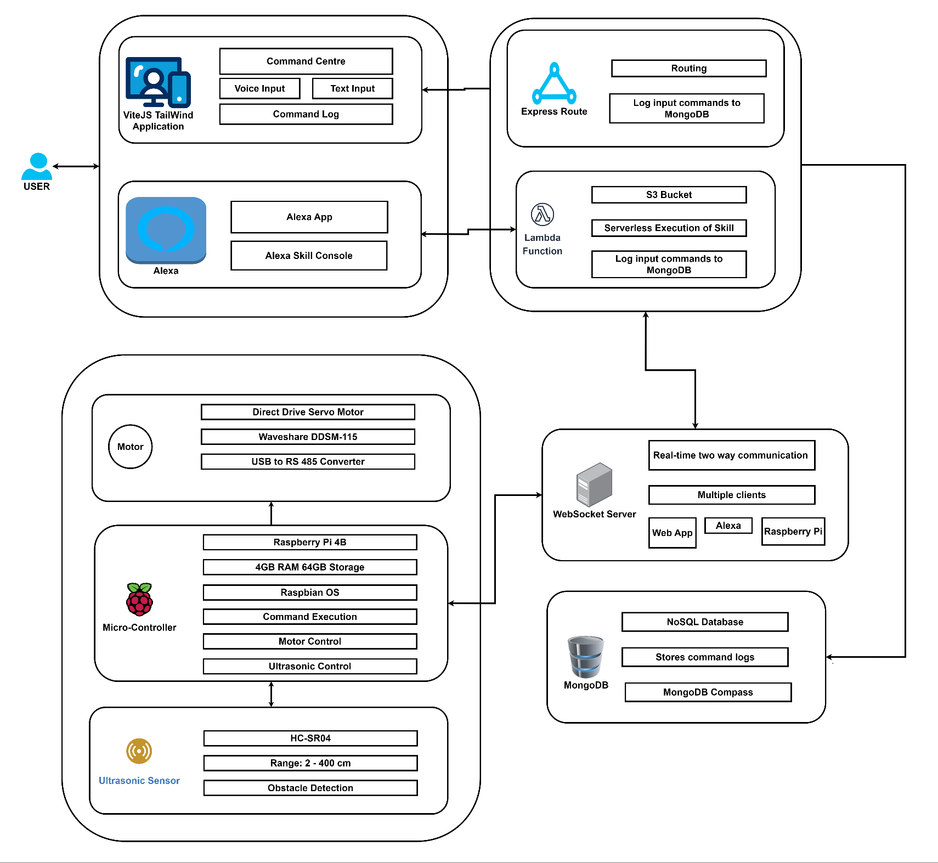

**TECHNOLOGY STACK:**

**Frontend:** React-Vite, Tailwind-CSS, Alexa Skills

**Backend:** WebSocket Server, MongoDB

**Backend API:** WebSocket API

**Middleware:** Express.js, AWS Lambda, S3 Bucket

**Deployment:** Vercel, AWS

**Operating System:** Raspbian OS

**Hardware:** RaspberryPi 4B, DDSM115 Motor Hub, RS-485 to USB Converters, HC-SR04 Ultrasonic Sensor, Alexa Echo Dot, Step-Up Transformer.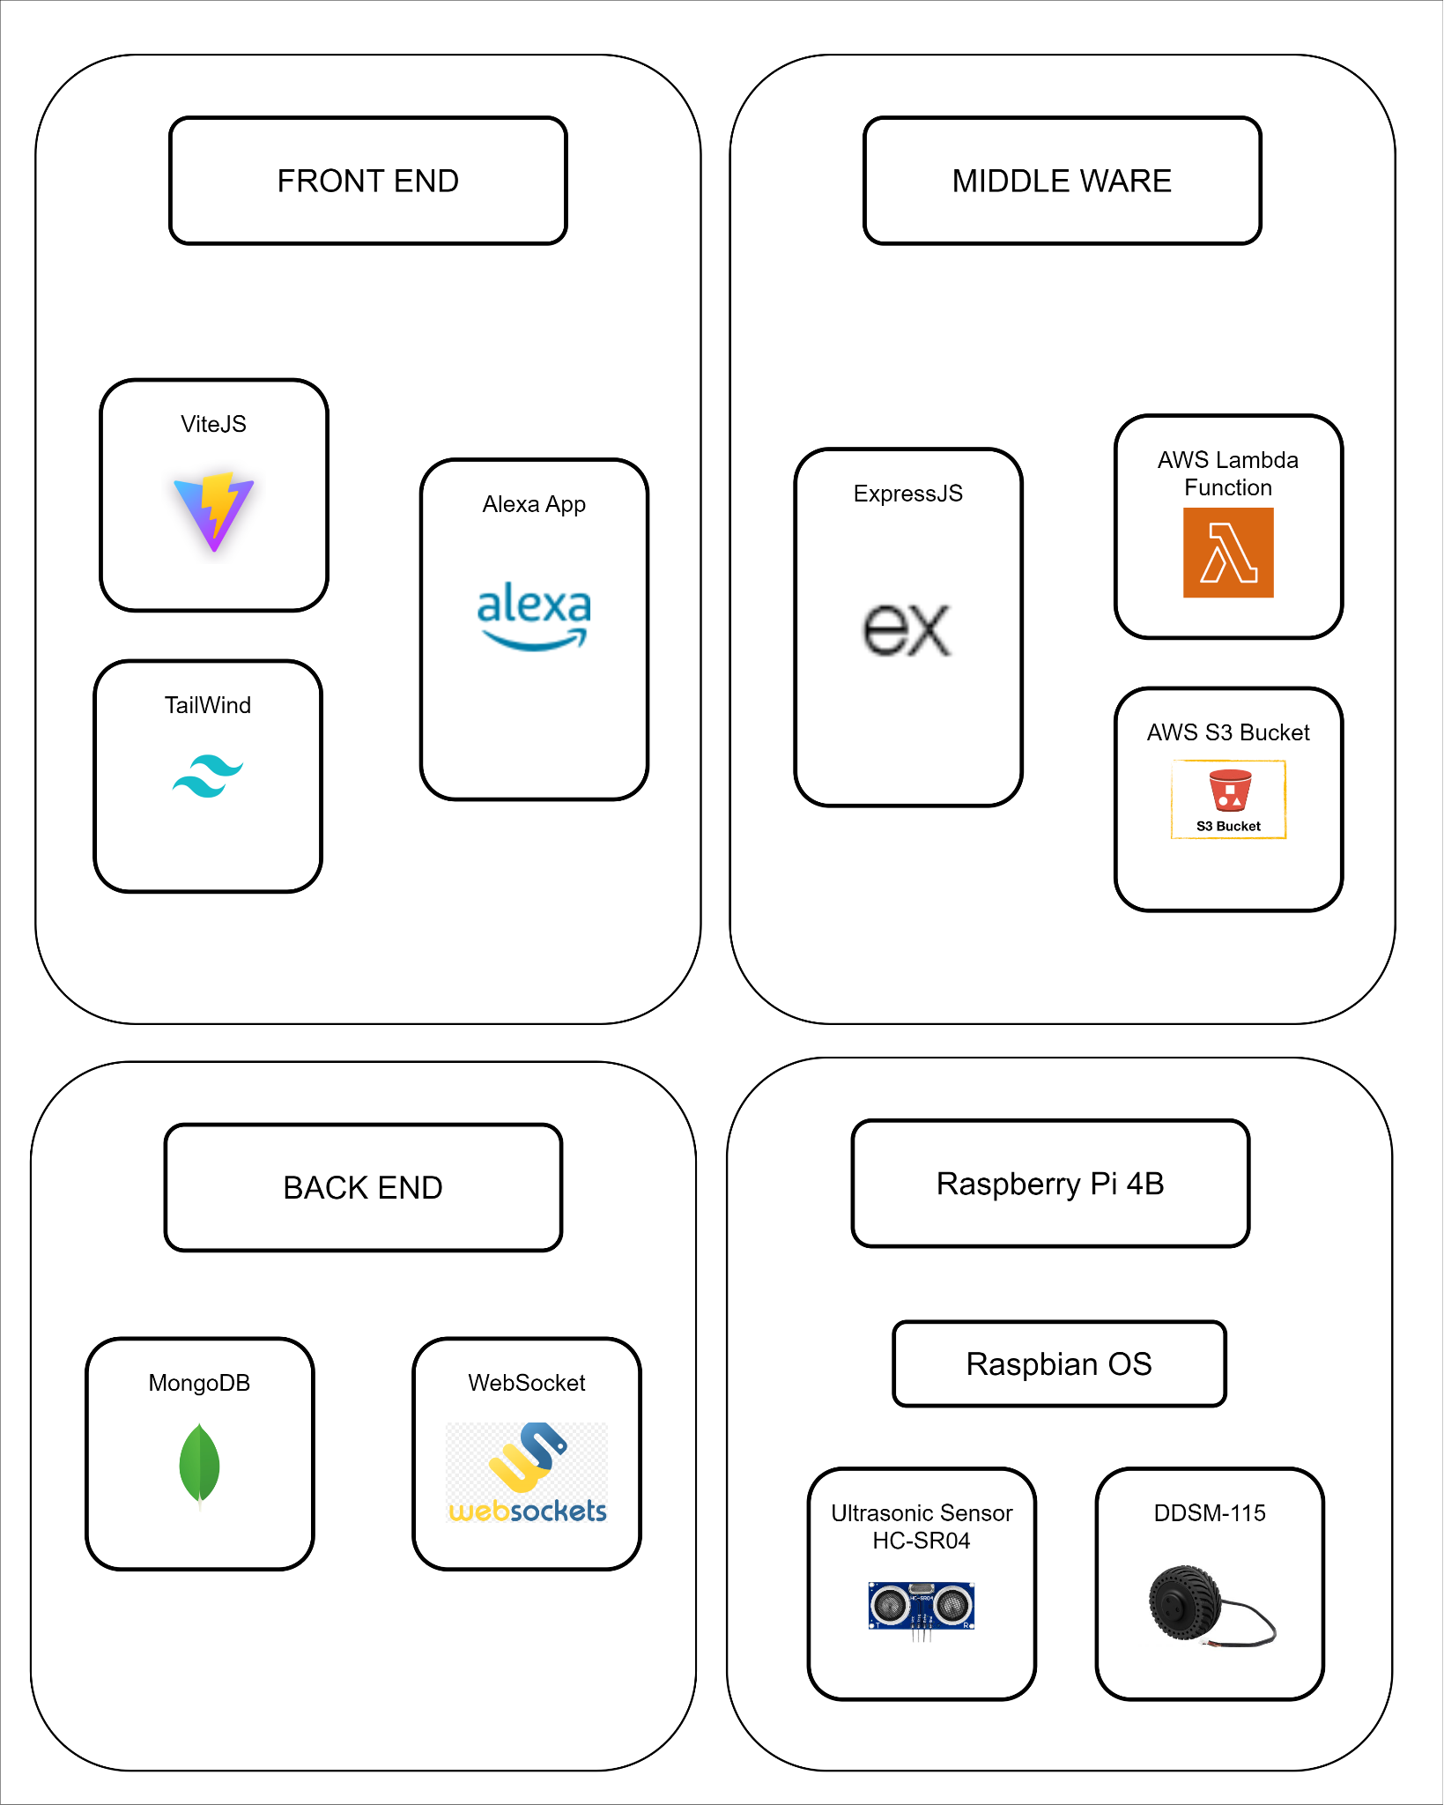

**STRUCTURAL OVERVIEW:**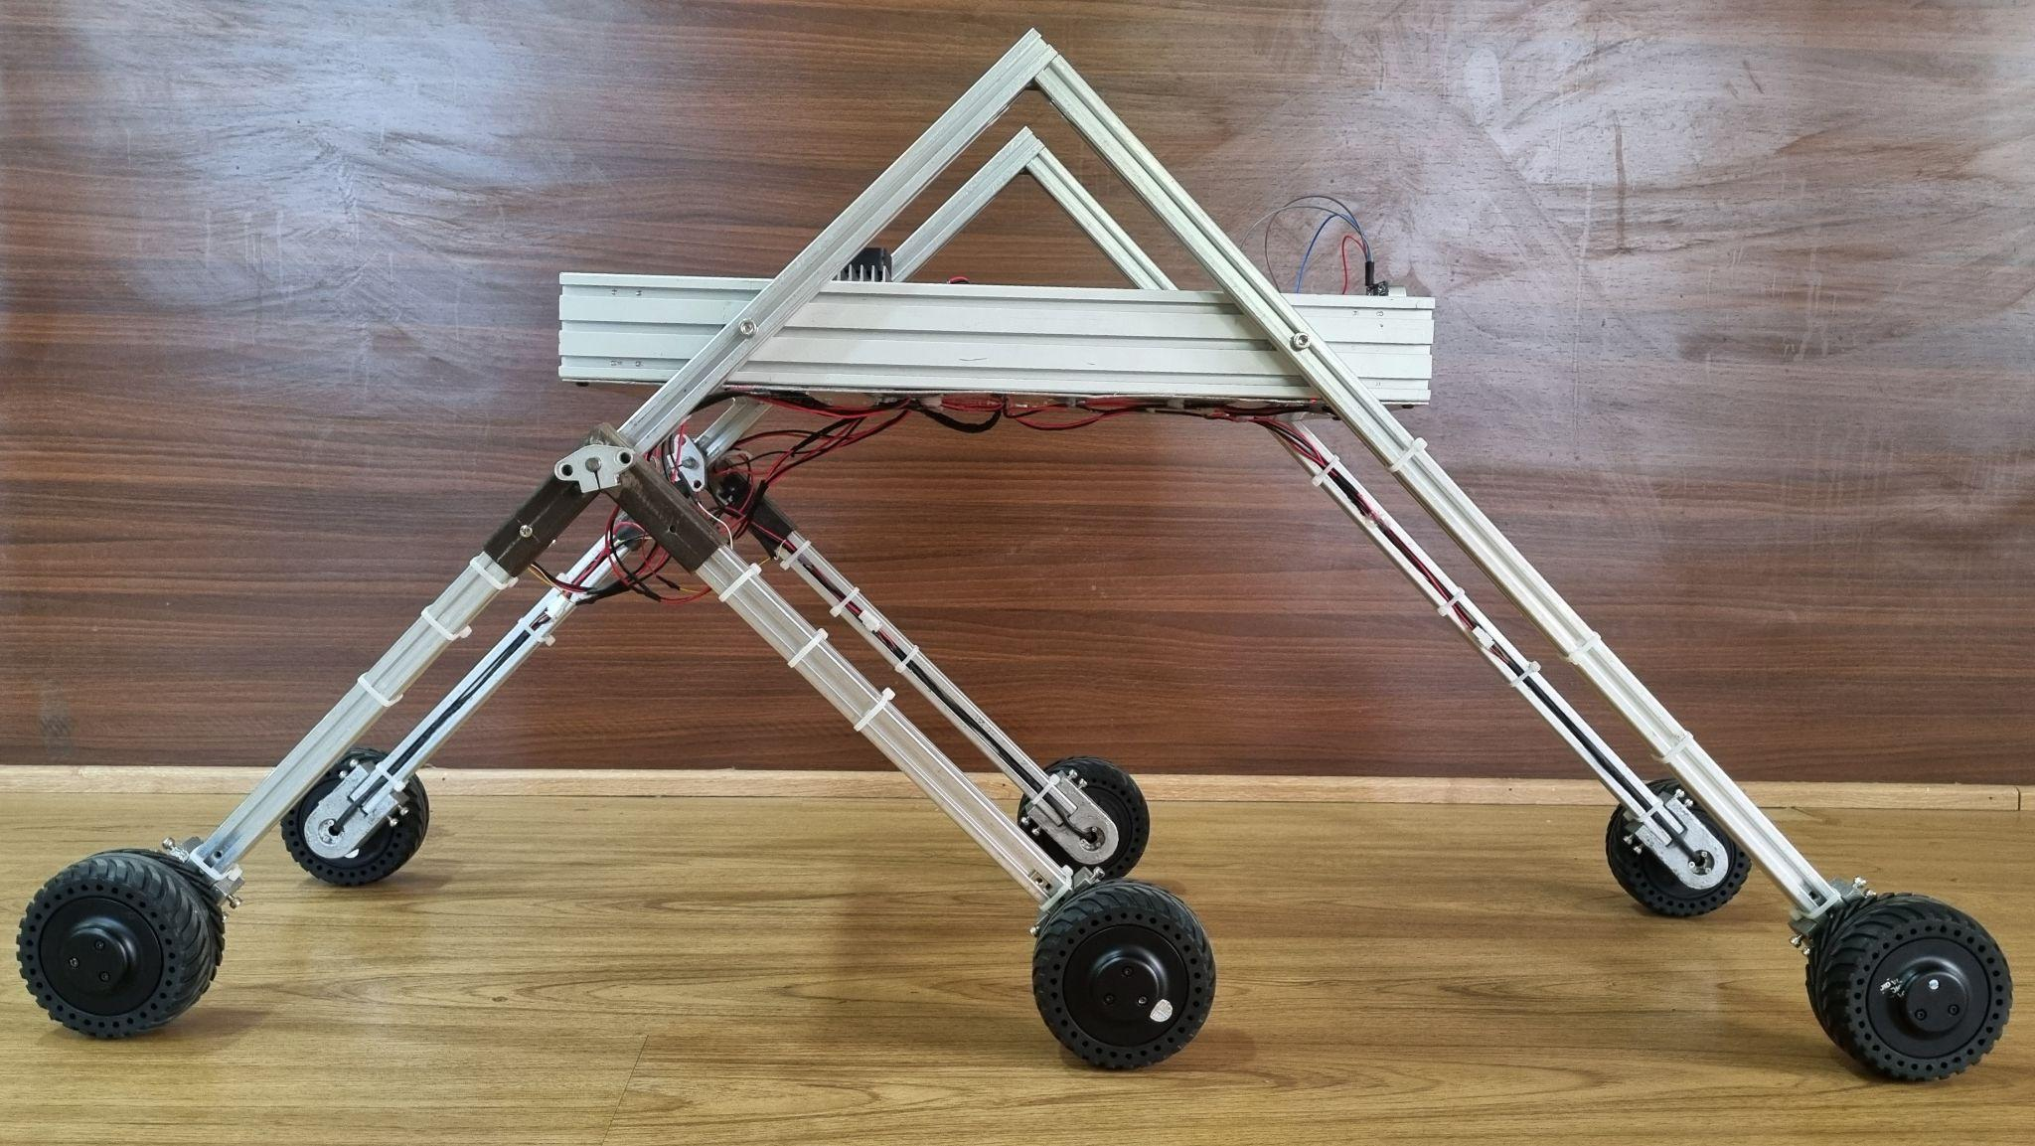

1)Side View

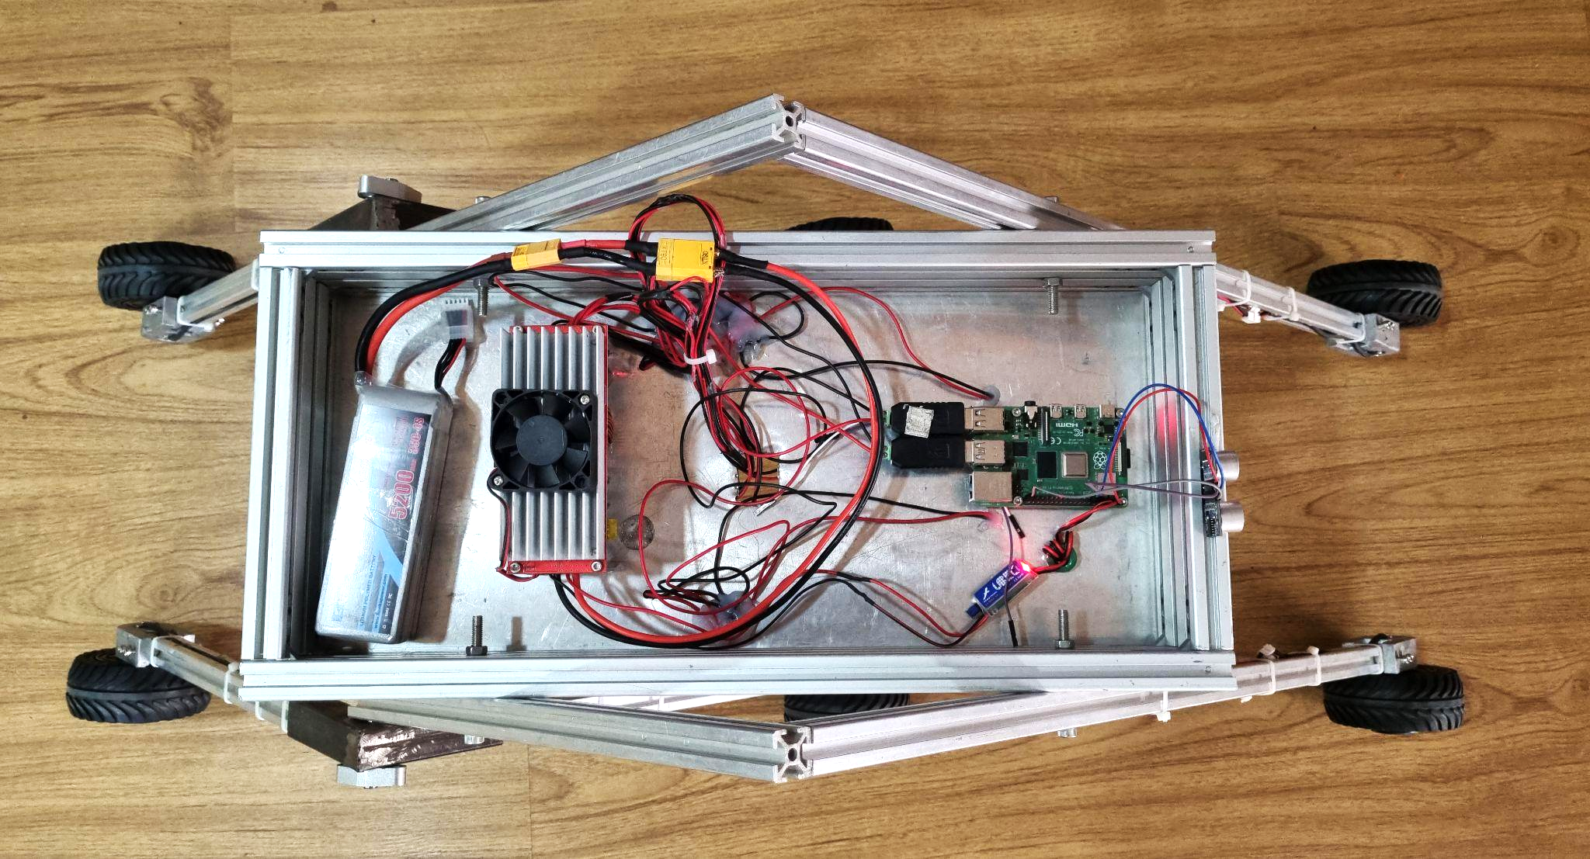

2)Top View

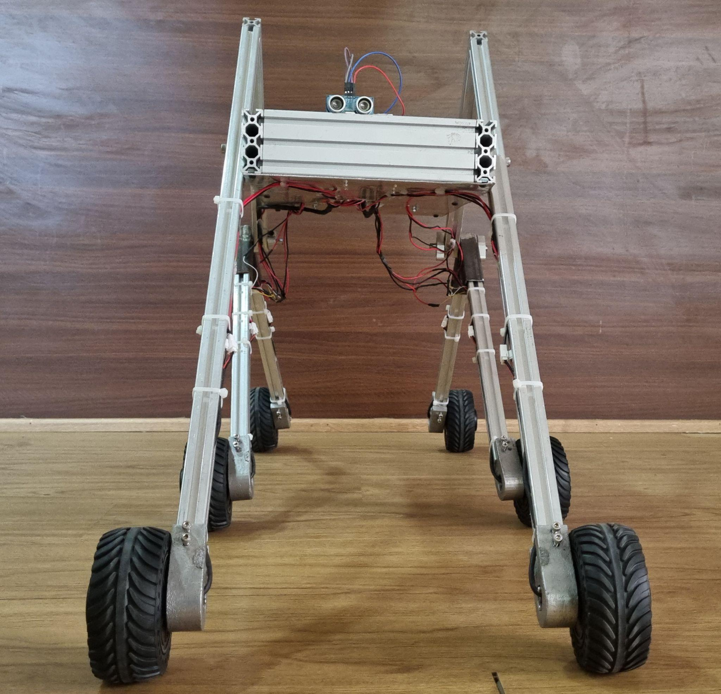

3)Front View

The basic structure consists of a Raspberry pi MicroController(mounted on the car) which has the power source,ultrasonic sensor and the motor hub connected through the RS-485 connector.The six motors are connected in 2 channels which are powered by a 4 cell Lithium Ion battery, via a step-up transformer to achieve the recommended voltage.The ultrasonic sensor is connected and controlled through the GPIO pins which are connected to the Raspberry Pi MicroController.

**MICROPROCESSOR:**

The microcontroller used for this project is Raspberry Pi 4B.

Raspberry Pi provides the best core for our smart car. Its miniature, lightweight nature, combined with the unit’s low price, makes it simply perfect. It offers ground-breaking increases in processor speed, multimedia performance, memory, and connectivity.This model is a powerful and versatile computer that can be used for a wide variety of purposes.

Some of its features are:

* 1.5 GHz quad-core 64-bit ARM Cortex-A72 CPU
* 1GB, 2GB, 4GB, or 8GB of LPDDR4-3200 SDRAM
* 2 micro-HDMI ports supporting up to 4Kp60 resolutions
* 2 USB 3.0 ports and 2 USB 2.0 ports
* Gigabit Ethernet port
* 802.11ac Wi-Fi and Bluetooth 5.0
* 40-pin GPIO header

The Raspberry Pi supports various programming languages like Python, C++, and Java, allowing you to choose the best fit for your skills and project requirements. With its GPIO pins and HATs (Hardware Attached on Top), you can connect motors, sensors, cameras, microphones, and other components, providing immense flexibility for customization.The small size and low power consumption make the Raspberry Pi ideal for portable projects, letting you take your smart car anywhere.

Its open-source nature and large community support make it a perfect platform for learning and experimentation, giving you the flexibility to create a truly unique and functional smart car.

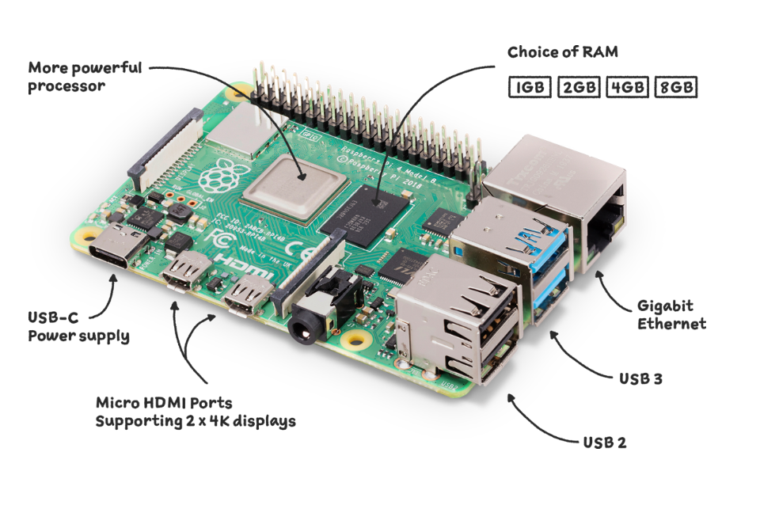

**ALEXA SKILLS:**

To enhance the functionality and user experience of our voice-controlled car project, we considered integrating Alexa skills. Alexa skills are essentially mini-apps that expand the capabilities of our Amazon Echo device, allowing us to control various aspects of your life using voice commands. In the context of our project, Alexa skills can act as a bridge between your user's voice commands and the Raspberry Pi that controls your car.

By creating a custom Alexa skill, we enable users to control their voice-controlled car with simple voice commands. For example, if we could say "Alexa,open smart car" or "Alexa, turn left." The Alexa skill would then process these commands and send them wirelessly to the Raspberry Pi, which would subsequently instruct the car to perform the desired actions.

**AWS(Amazon Web Services):**

* **AWS Lambda**

AWS Lambda is a compute service that lets you run code without provisioning or managing servers. Lambda runs your code on a high-availability compute infrastructure and performs all of the administration of the compute resources, including server and operating system maintenance, capacity provisioning and automatic scaling, and logging. With Lambda, all you need to do is supply your code in one of the language runtimes that Lambda supports(for example: Python, Node.js). You only organize our code into the lambda function. The lambda service runs our function only when you need it and it scales automatically.

When using Lambda, you are responsible only for your code. Lambda manages the compute fleet that offers a balance of memory, CPU, network, and other resources to run your code. Because Lambda manages these resources, you cannot log in to compute instances or customize the operating system on provided runtimes.

Lambda ideals compute service for application scenarios that need to scale up rapidly, and also scale down to zero when not in demand. For example:

• File Processing

• Stream processing

• Web applications

• IoT backend

• Mobile backends

**Lambda Code**:

**The Required Libraries with the required versions are**:

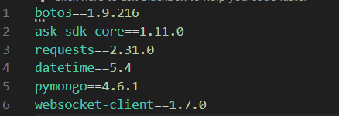

**Description of the libraries:**

* **boto3 (version 1.9.216)**: This library allows you to interact with Amazon Web Services (AWS) services like S3, EC2, and DynamoDB from your Python code.
* **ask-sdk-core (version 1.11.0)**: This library provides the core functionality for building Alexa skills, including handling user intents, managing sessions, and generating responses.
* **requests (version 2.31.0)**: This popular library simplifies making HTTP requests from Python applications, used for communication with web servers.
* **datetime (version 5.4)**: This built-in Python module provides functionalities for working with dates, times, and timedeltas, used for generating timestamps.
* **pymongo (version 4.6.1)**: This library enables interaction with MongoDB databases from Python, used for storing data
* **websocket-client (version 1.7.0)**: This library facilitates establishing and managing WebSocket connections, used for real-time communication

**Here is the basic code which is being used in the Lambda function:**

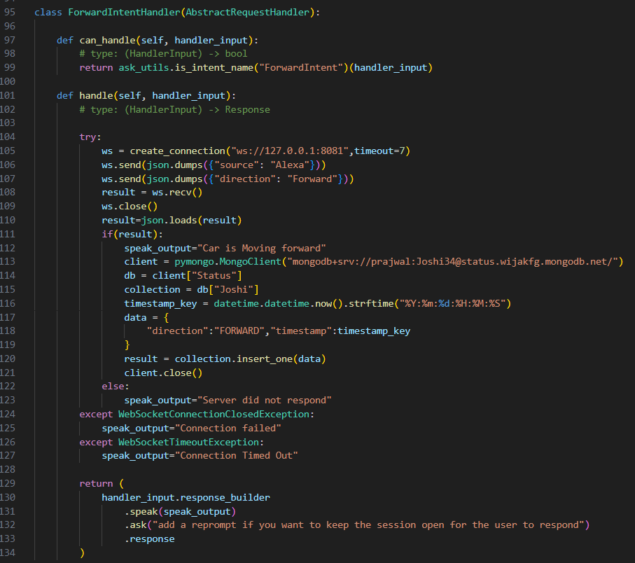

Here is the Code Explanation:

* **ForwardIntentHandler(AbstractRequestHandler)**:

This creates a class that inherits from AbstractRequestHandler, a base class likely used for handling user intents in a voice-based application.

* **can_handle(self, handler_input)**:

Determines if this class can handle a specific intent.Uses ask_utils.is_intent_name("ForwardIntent")(handler_input) to check if the incoming intent is named "ForwardIntent."Returns True if it's a match, enabling the handle method to execute

* **handle(self, handler_input)**:

This method activates when the "ForwardIntent" is detected.

* **Connects to a WebSocket**:

Uses create_connection to establish a WebSocket connection to a server at ws://127.0.0.1:8081 with a timeout of 7 seconds.

* **Sends Commands**:

Converts two messages to JSON and sends them through the WebSocket:*First message*: {"source": "Alexa"} (identifies the sender as Alexa). *Second message*: {"direction": "Forward"} (commands the forward action)

* **Receives Response**:

Waits for a response from the server and stores it in result.Closes the WebSocket connection.

* **Processes Response**:

If result exists (indicating a successful response):

Sets speak_output to "Car is Moving forward."

Connects to a MongoDB database using connection details and creates references to the database and collection.

Generates a timestamp and creates a dictionary data containing direction (FORWARD) and the timestamp.

Inserts the data into the MongoDB collection and closes the connection.

Otherwise (no response or error):

Sets speak_output to "Server did not respond" or specific error messages based on exceptions.

* **Builds and returns a response:**

Similar to the previous code, this section constructs and returns a response using handler_input.response_builder.

**AWS S3:**

The API of Alexa that we are using cannot be compressed into a zip file which is less than 10MB. So we are using another AWS service which is S3 bucket.

Amazon Simple Storage Service (Amazon S3) is an object storage service that offers industry-leading scalability, data availability, security, and performance. Customers of all sizes and industries can use Amazon S3 to store and protect any amount of data for a range of use cases, such as data lakes, websites, mobile applications, backup and restore, archive, enterprise applications, IoT devices, and big data analytics. Amazon S3 provides management features so that you can optimize, organize, and configure access to your data to meet your specific business, organizational, and compliance requirements.

**WEBSOCKET SERVER:**

**Libraries:**

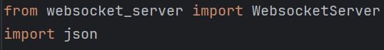

**websocket_server :** Simpler implementation for basic WebSocket server functionality

**json** : Provides functions to convert python objects

**Functions:**

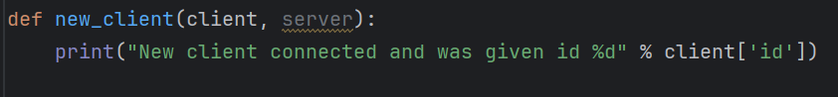

**New_client** **:** Prints if a new client joins the websocket server.

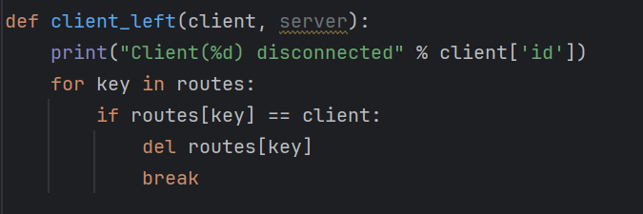

**client_left :** The function takes two parameters: client and server. The client parameter is a dictionary that contains information about the client that just disconnected. The server parameter is the WebSocket server instance. The function first prints a message to the console indicating that a client has disconnected, including the client's ID. Then, it iterates over the keys in the routes dictionary. The routes dictionary seems to map sources (like 'Alexa', 'Raspberry Pi', etc.) to their respective client instances. If it finds a key in routes that maps to the client that just disconnected, it removes that key-value pair from the routes dictionary and breaks the loop. This effectively removes the disconnected client from the routes mapping.

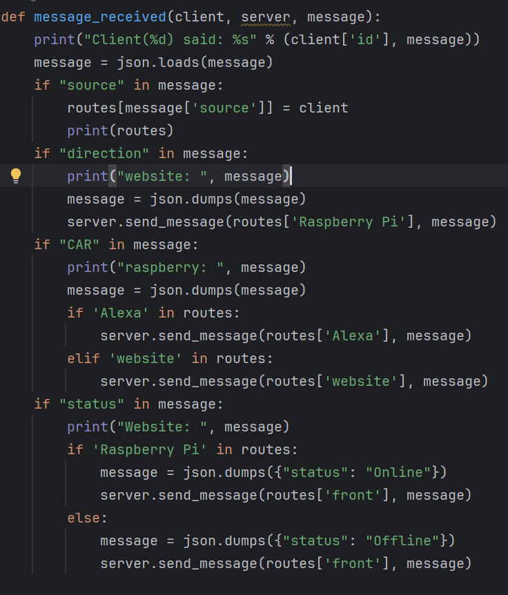

**Message_received :** Handles incoming messages from clients in a WebSocket server context. It parses the message, checks for certain keys, and performs actions based on these keys. If the message contains a 'source', it updates the routes dictionary. If it contains a 'direction' or 'CAR', it sends a message to the appropriate client. If it contains a 'status', it sends an online or offline status to the 'front' route.

**Initialization of WebSocket Server**

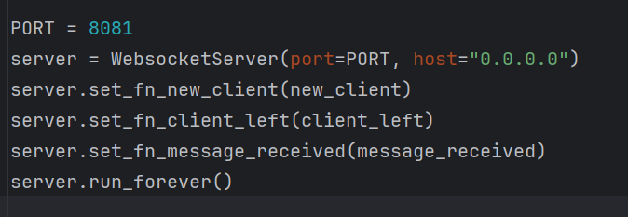

Initializes a WebSocket server on port 8081 and binds the functions new_client, client_left, and message_received to handle new connections, client disconnections, and incoming messages respectively. The server then runs indefinitely.

**MOTOR HUB(DDSM-115):**

For the mobility of our car, we have used DDSM-115 Motor which is a high-reliability Permanent Magnet Synchronous Motor (PMSM) integrating an outer rotor brushless motor, encoder, and servo. With a compact structure, it is easy to install and can be operated stably. As it is small while with high torque, it can be applied for the following advanced robot projects such as robot joints, small AGV drive wheels, balance car drive wheels, and the development of vehicle platforms.

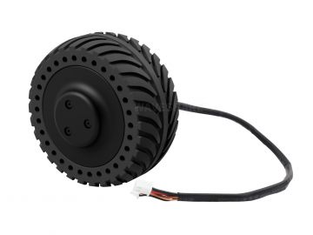

Features:

* Ultra-low noise
* High precision and zero-backlash
* Fast response, direct drive without delay
* Integrated motor and driver, compact structure and high integration
* Support RS485 communication mode
* Motor feedback information such as position, speed, current, error code, etc. can be obtained through communication.
* With Hall position detection, over-current protection, etc.
* Support electric brake

Parameters:

* No-load speed: 200±10rpm
* No-load current: ≦0.25A
* Rated speed: 115 rpm
* Rated torque: 0.96Nm
* Rated current: 1.5A
* Rated voltage: 18V DC (5S LiPo)
* Voltage range: 12-24V DC
* Total weight: 765±15g
* Noise level: ≦50dB
* Degree of protection: IP54
* Single-wheel load: 10kg

Communication Protocol:

* Baud Rate: 115200
* Data bits: 8bit
* Stop bit: 1 bit
* Data length: 10 bytes
* Rate: up to 500Hz
* In speed loop mode: -330~330, unit rpm, data type signed 16-bit

The commands are sent through a serial port assistant as hex codes, which are converted into binary and sent to the motor, here are some examples.

Brake : 01 64 00 00 00 00 00 FF 00 D1

100 RPM : 01 64 FF 9C 00 00 00 00 00 9A

**WEBSITE INTERFACE:**

* **FRONT END**

React-Vite web application designed to control the connected car through voice and text inputs. Its user-friendly interface offers access to essential functionalities and interaction logs.

**System Overview**

**Components:**

· **Home Page:** Showcases project information.

* **Navigation bar:** Provides access to:
  + **Log:** Displays a comprehensive history of car interactions stored in MongoDB (voice/text commands).
  + **Input:** Allows user input for car control, via:
    - **Voice:** Utilizes Web Speech API to capture and convert voice commands to text for car interaction. Includes utterance handling for added flexibility.
    - **Text:** Provides a text field for manual command input.
  + **About Us:** Showcases developer details.
  + **Status:** Checks whether the car is online.
* **Technology Stack:**
  + **React:** JavaScript library for building user interfaces.
  + **Vite.js:** Modern build tool for developing and optimizing React applications.
  + **Tailwind and Material-Tailwind:** Frameworks used for building responsive and styling the UI.
  + **Web Speech API:** Enables capturing user voice inputs through the browser and improves flexibility with utterance handling.

**Command Centre:**

**Voice Input:**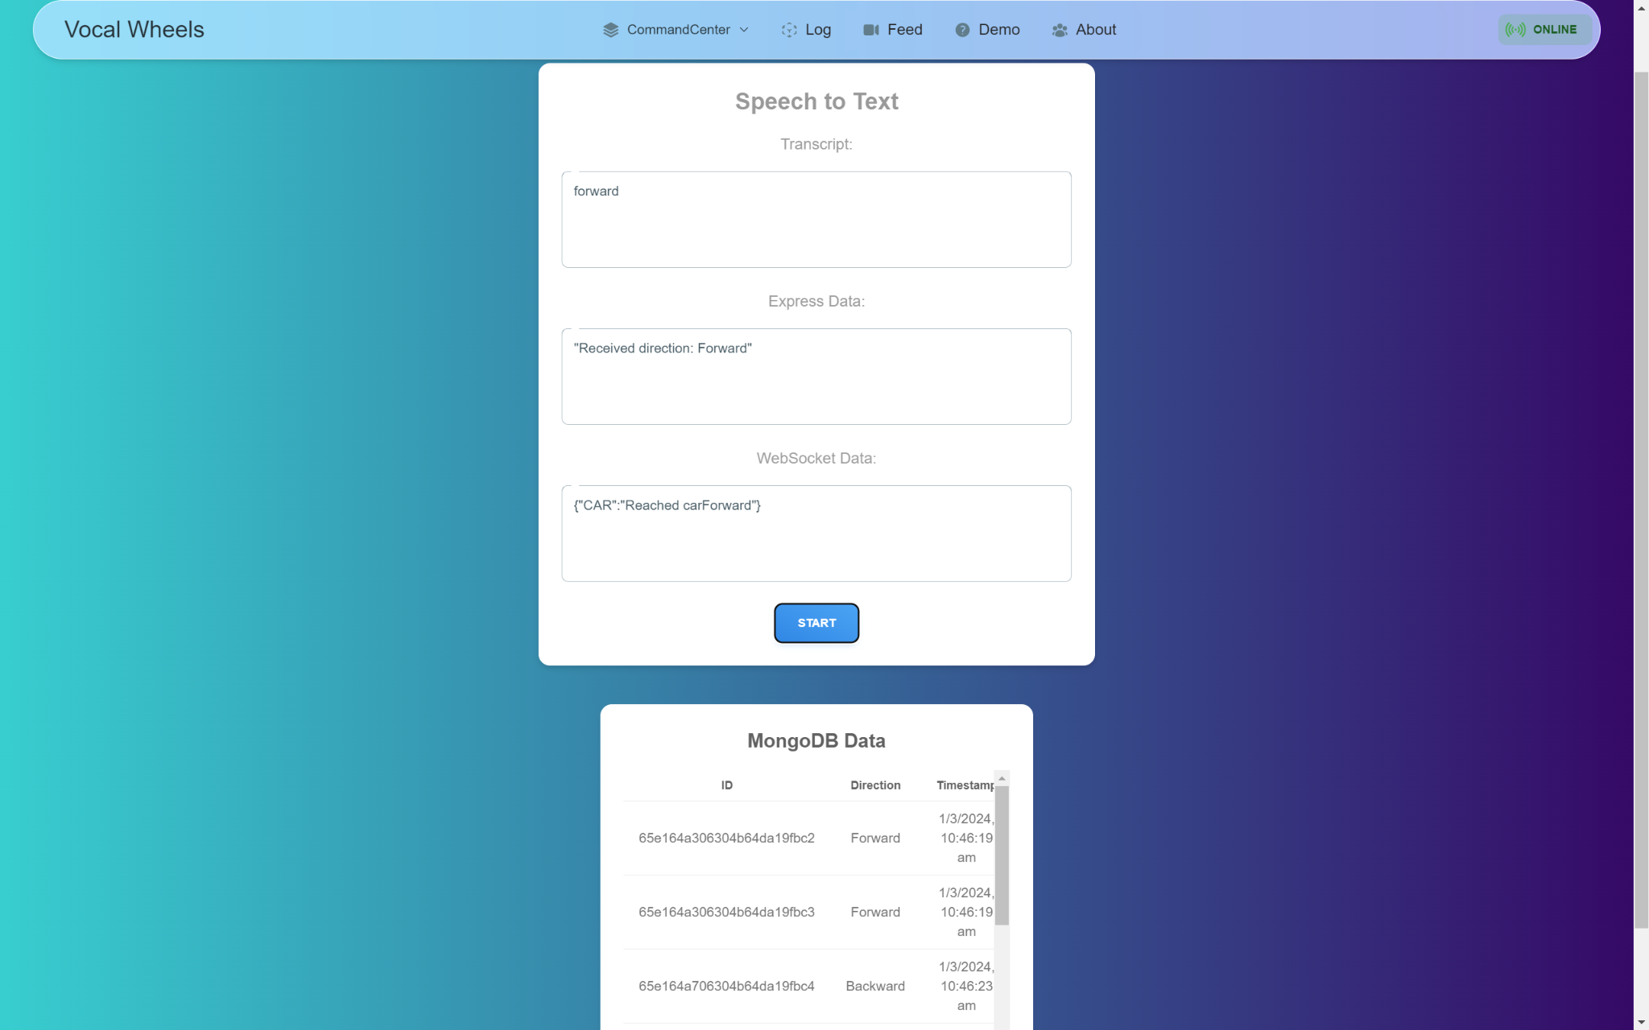

This is a React component that uses the Web Speech API to convert speech to text.

It maintains state for the transcript, server response, and data from MongoDB, Express, Flask, and a WebSocket connection.

The startRecognition and stopRecognition functions control the speech recognition process.

The sendPostRequest function sends a POST request to a server with a command derived from the spoken words.

The handleFinalResult function is called when the speech recognition process produces a final result, converting the spoken words into a command and sending this command to the server.

The component's render method returns a JSX element that displays the transcript, server response, and data from MongoDB, Express, Flask, and the WebSocket connection.

**Text Input:**

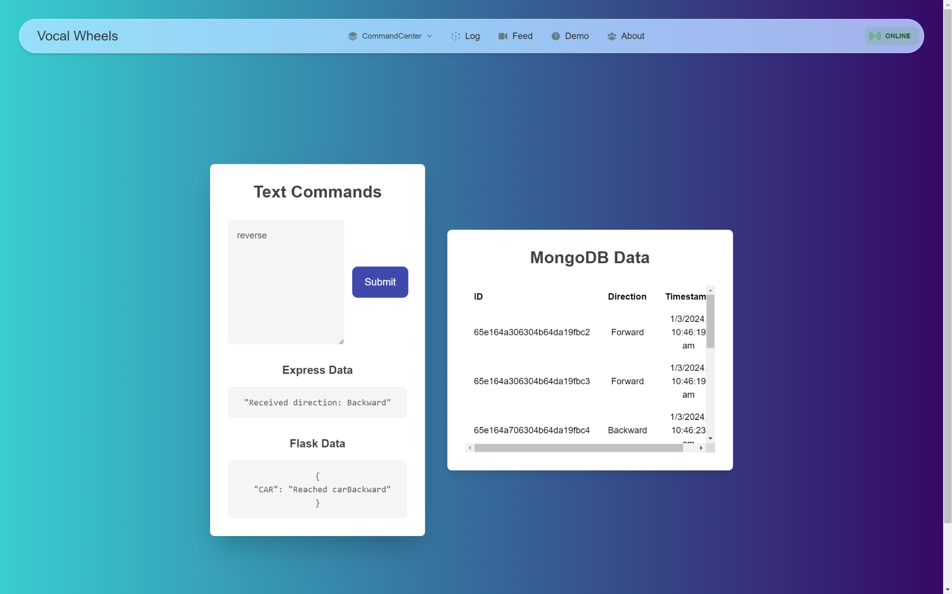

This is a React component named TextInput that takes user input, converts it to a command, and sends it to a server.

It maintains state for the command, and data from MongoDB, Express, Flask, and a WebSocket connection.

The utteranceToCommand object maps spoken commands to actual commands.

The sendPostRequest function sends a POST request to a server with the command, and updates the state with the response data.

The handleCommand function converts the user input to a command and calls sendPostRequest.

The component's render method returns a JSX element that displays a text input for the command, a submit button, and the data from MongoDB, Express, Flask, and the WebSocket connection.

**Control Log Database**

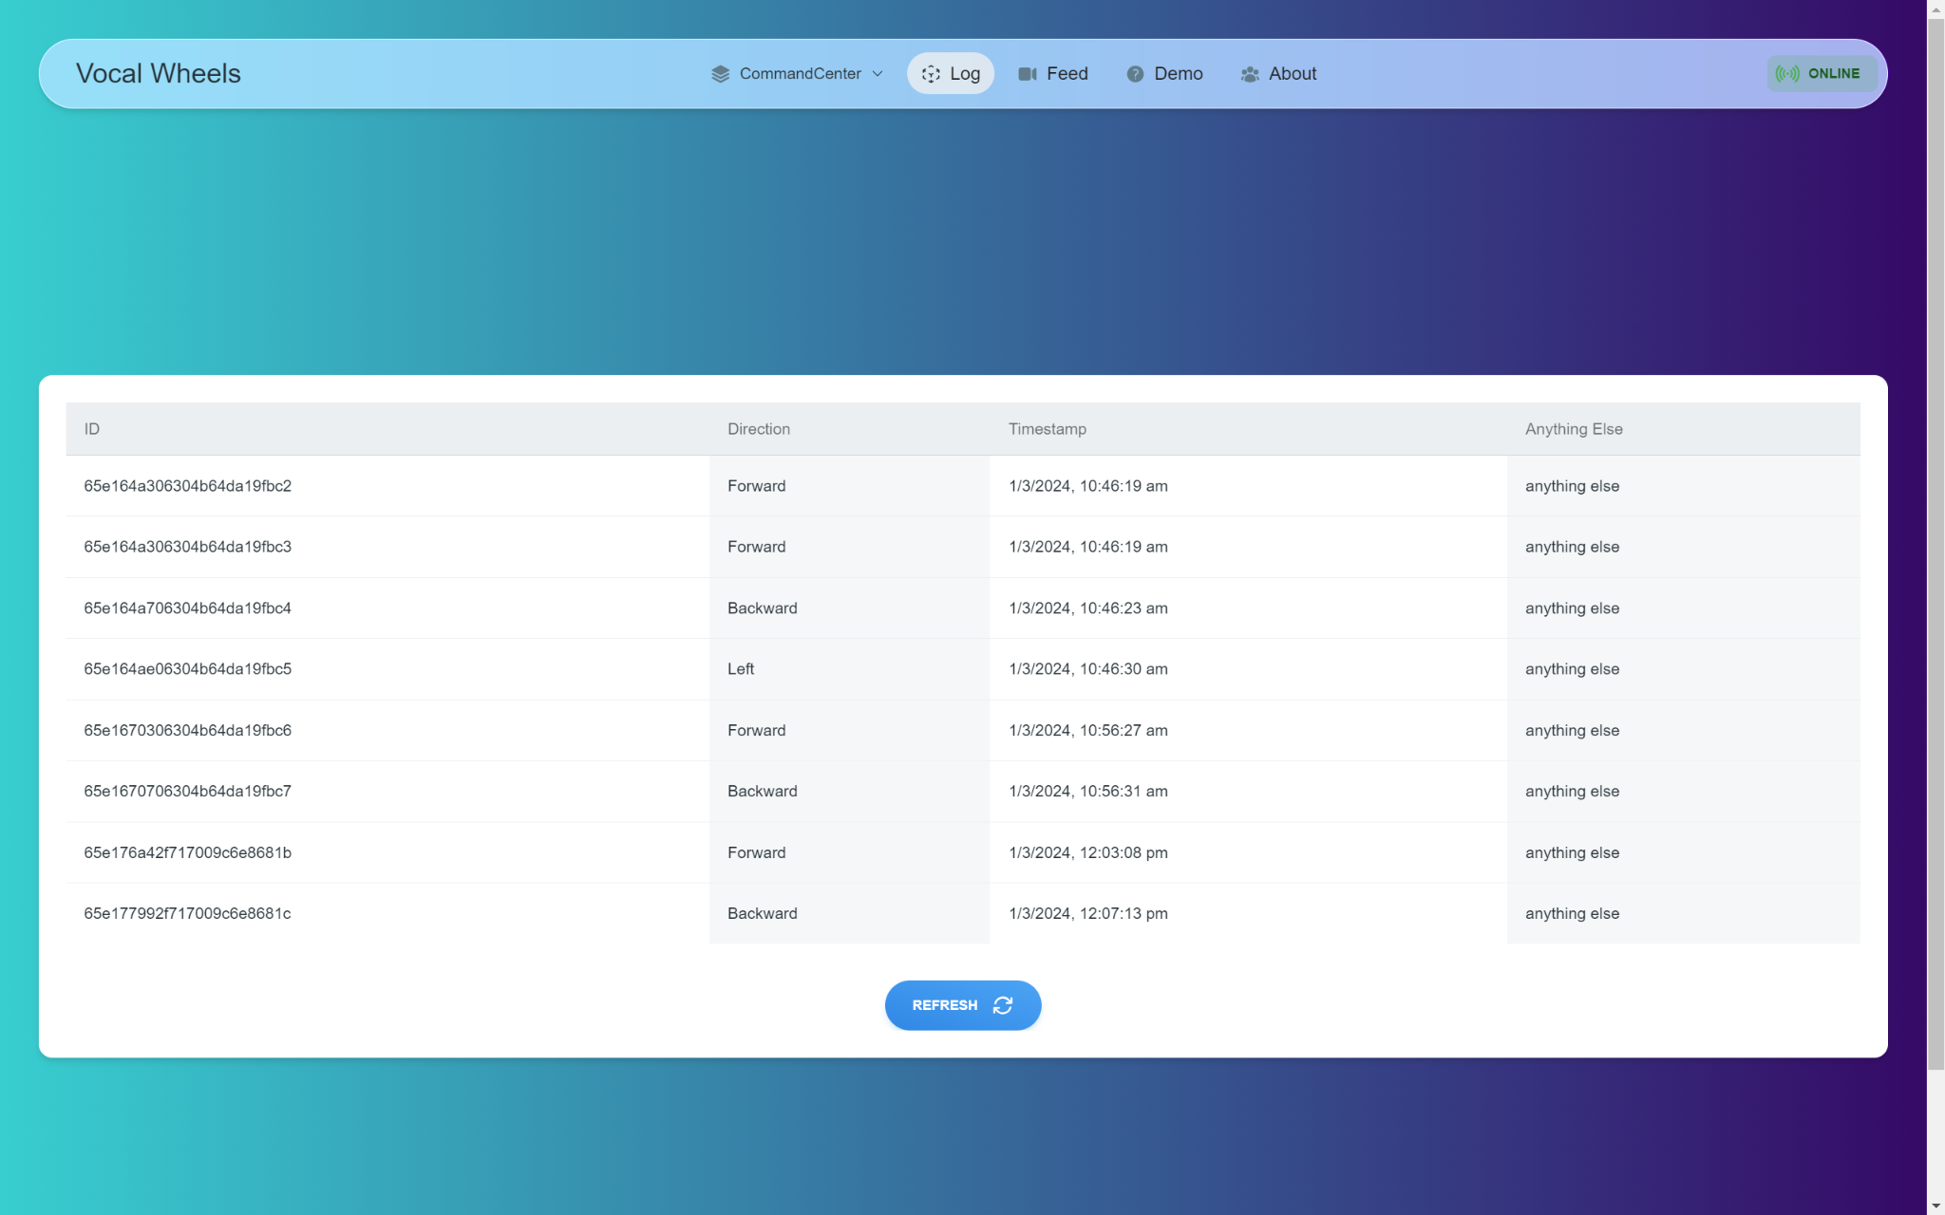

**Functionalities:**

* Voice/Text Control: Users can issue commands to the car via voice or text input, offering accessibility and convenience.
* Command History: The log component retains a record of all interactions, enabling review and troubleshooting.
* Modular Design: Each component serves a specific purpose, facilitating future feature additions and maintenance.
* **MIDDLEWARE:**

This Node.js application serves as an API that interacts with a MongoDB database and a Flask server to facilitate data exchange and status checks.

**ExpressJS Server:**

**Libraries:**

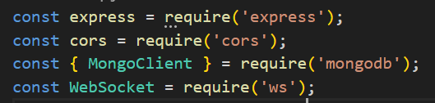

This code is importing necessary modules for a Node.js application:

1. express is a web application framework for Node.js, designed for building web applications and APIs.
2. cors is a middleware that can be used to enable Cross Origin Resource Sharing (CORS) in our Express application.
3. MongoClient is a class from the mongodb driver that allows you to connect to a MongoDB server and issue commands.
4. WebSocket is a class from the ws library for creating WebSocket clients and servers

**Variable Initialization:**

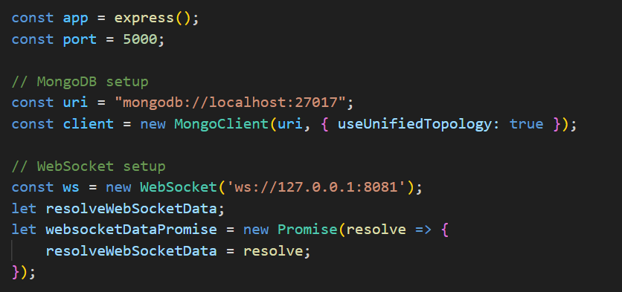

This code is setting up an Express application and preparing connections to MongoDB and a WebSocket server:

1. An Express application is created and assigned to app, and the port number for the server is set to 5000.
2. A MongoDB client is created with the connection string mongodb://localhost:27017 and the option { useUnifiedTopology: true } to use the new MongoDB driver topology engine.
3. A WebSocket client is created and connected to the WebSocket server at ws://localhost:8081.
4. A Promise websocketDataPromise is created, which will be resolved when data is received from the WebSocket server. The resolve function of this Promise is stored in resolveWebSocketData.

**Handle Connections:**

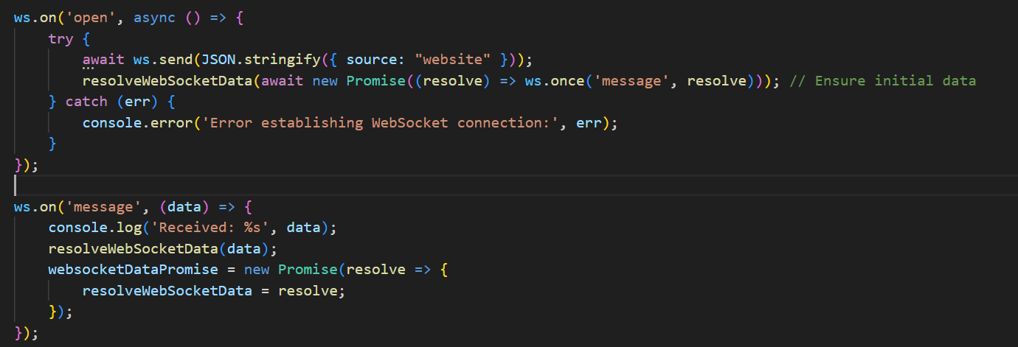

This code is handling WebSocket events:

1. When the WebSocket connection is opened (ws.on('open')), it sends a message { source: "website" } to the WebSocket server and waits for the first message from the server to resolve the websocketDataPromise.
2. If there's an error during this process, it logs the error message.
3. When a message is received from the WebSocket server (ws.on('message')), it logs the message, resolves the websocketDataPromise with the received data, and creates a new Promise for the next message.

**Initialization of CORS and Fetch latest data:**

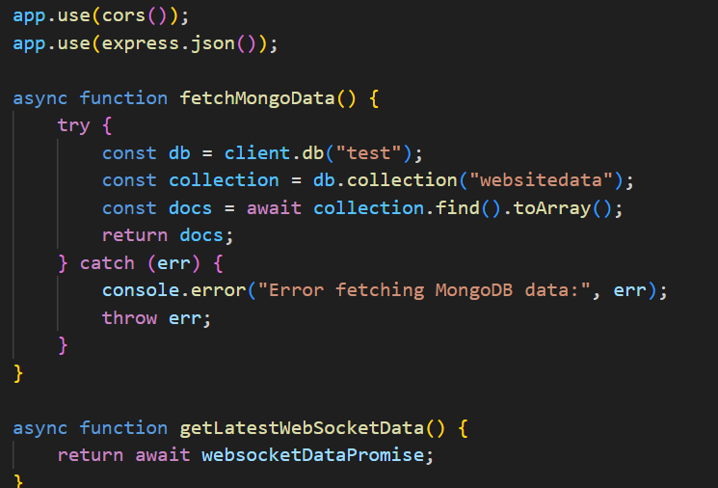

This code is setting up middleware for an Express application and defining a function to fetch data from MongoDB:

1. app.use(cors()) enables Cross-Origin Resource Sharing (CORS) on the Express application, allowing it to accept requests from different origins.
2. app.use(express.json()) enables the Express application to parse incoming requests with JSON payloads.
3. fetchMongoData() is an asynchronous function that connects to a MongoDB database, fetches documents from a collection, and returns them. If there's an error during this process, it logs the error and rethrows it

**Send MongoDB logs to Front End**:

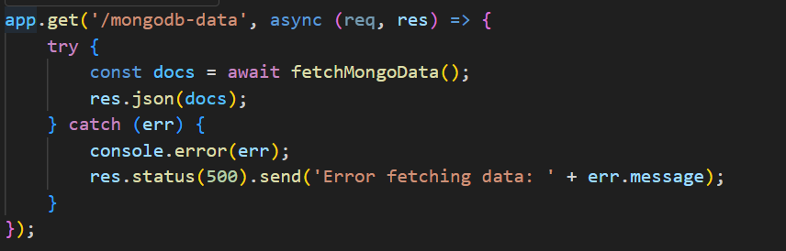

This code defines an Express route handler for GET requests to the /mongodb-data endpoint:

1. When a request is received, it calls the fetchMongoData() function to fetch data from MongoDB.
2. If the data is fetched successfully, it sends the data back to the client as a JSON response.
3. If there's an error during this process, it logs the error and sends a 500 Internal Server Error response with an error message

**Handles Data Routing:**

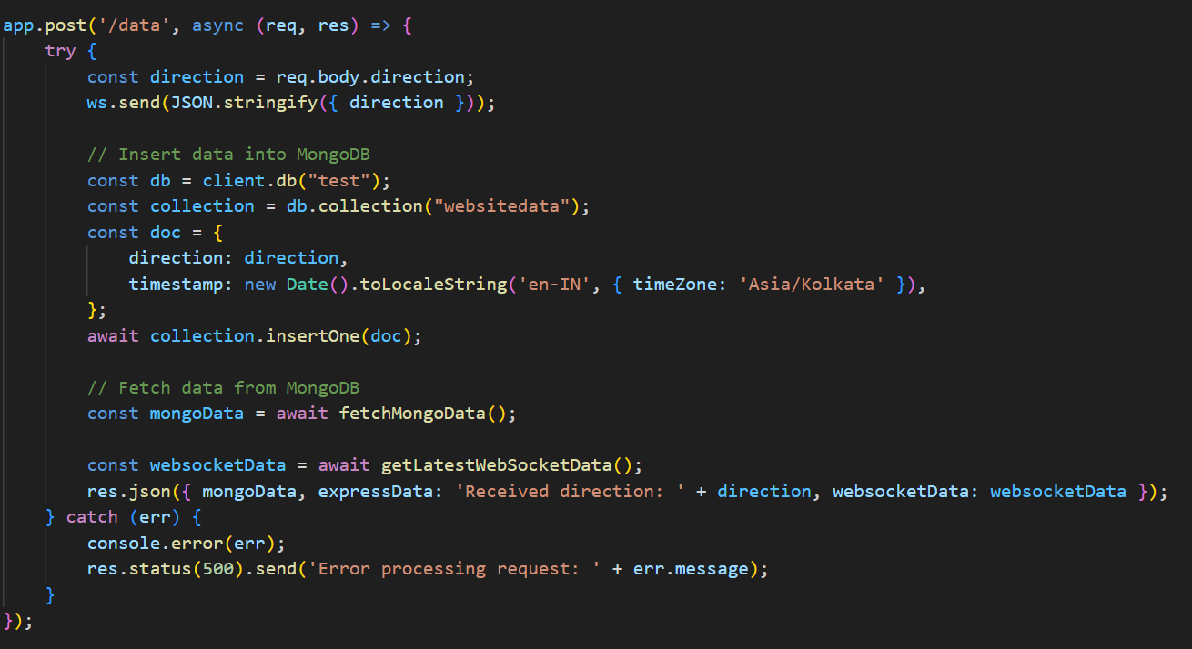

This code defines an Express route handler for POST requests to the /data endpoint:

1. It reads the direction property from the request body and sends it to a WebSocket server.
2. It inserts a document into a MongoDB collection, with the direction and the current timestamp.
3. It fetches data from the MongoDB collection and waits for the latest data from the WebSocket server using Promise.all().
4. If both operations are successful, it sends the fetched data back to the client as a JSON response.
5. If there's an error during this process, it logs the error and sends a 500 Internal Server Error response with an error message.

* **Key Functionalities:**

**Receiving and storing data from clients:**

* Accepts POST requests to the /example endpoint to receive a "direction" value from clients.
* Stores the received data, along with a timestamp, in a MongoDB database named “VocalWheels” with a collection named “Status”.

**Retrieving stored data:**

Provides a GET endpoint at /mongodb-data to fetch and return all documents from the "website data" collection.

**Communicating with a Flask server:**

Upon receiving data at /example, it forwards the "direction" value to a Flask server for further processing.

Includes the response from the Flask server in its own response to the client.

**Checking server status:**

Offers a GET endpoint at /checkStatus to check the status of the Flask server by attempting to access its /Status endpoint.

Returns a response indicating whether the Flask server is online or offline.

**Key Technologies**:

**Node.js:** The core runtime environment for the application.

**Express.js:** A Node.js web framework for building web applications and APIs.

**MongoDB:** A NoSQL database used for data storage.

**Axios:** A library for making HTTP requests to external servers (e.g., the Flask server).

**Additional Notes:**

The code includes comments for better readability and understanding.

It's configured to connect to a MongoDB database running either locally or on a MongoDB Atlas cluster.The Flask server URL is specified in the axios.post and axios.get calls, allowing for customization.

Error handling is implemented to catch potential issues with database connection or communication with the Flask server.

**Ultrasonic Sensor(HC-SR04):**

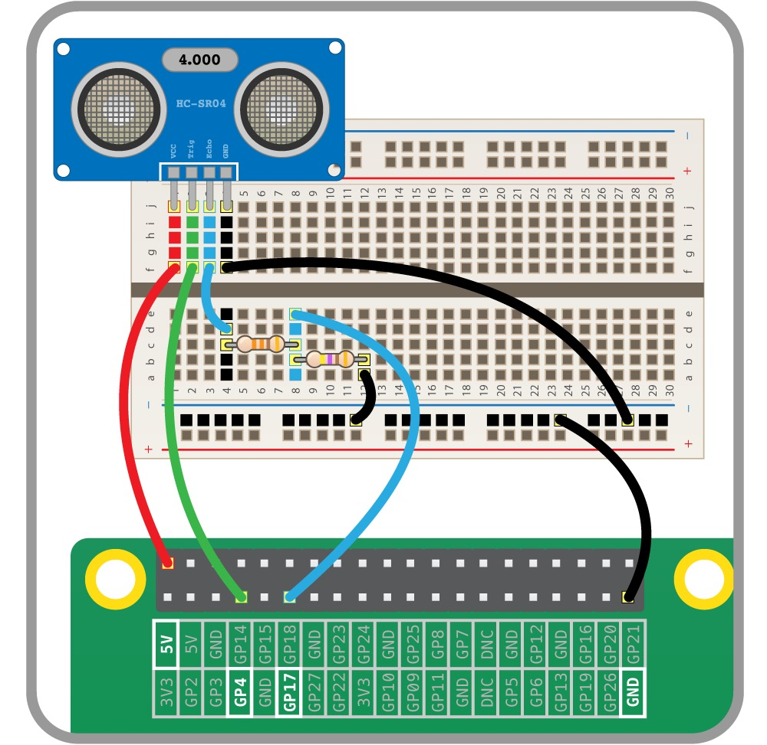

* We are using HC-SR04 Ultrasonic sensor for object detection in our car.
* The above image is of the circuit diagram for our ultrasonic sensor.
* We are not using the resistors as they are not required for our project.

**Basic Code:**

To use the ultrasonic distance sensor in Python, we are setting GPIO 4 pin to trigger and GPIO 17 to Echo.

from gpiozero import DistanceSensor

ultrasonic = DistanceSensor(echo=17, trigger=4)

while True:

print(ultrasonic.distance)

**Code Explanation:**

* This code snippet uses the gpiozero library to measure distance with an ultrasonic sensor connected to a Raspberry Pi.
* **from gpiozero import DistanceSensor:**

This line imports the DistanceSensor class from the gpiozero library. This class allows you to easily control and read data from ultrasonic sensors.

* **ultrasonic = DistanceSensor(echo=17, trigger=4):**

This line creates an instance of the DistanceSensor class named ultrasonic. It configures the sensor to use GPIO pin 17 for the echo pin and GPIO pin 4 for the trigger pin. These pins are where the sensor receives and transmits ultrasonic pulses to measure distance.

* And at the end the while loop prints the distance continuously.

**DATABASE:**

The DataBase logging is implemented by mongodb(NoSQL DataBase)

It gets logged accordingly.

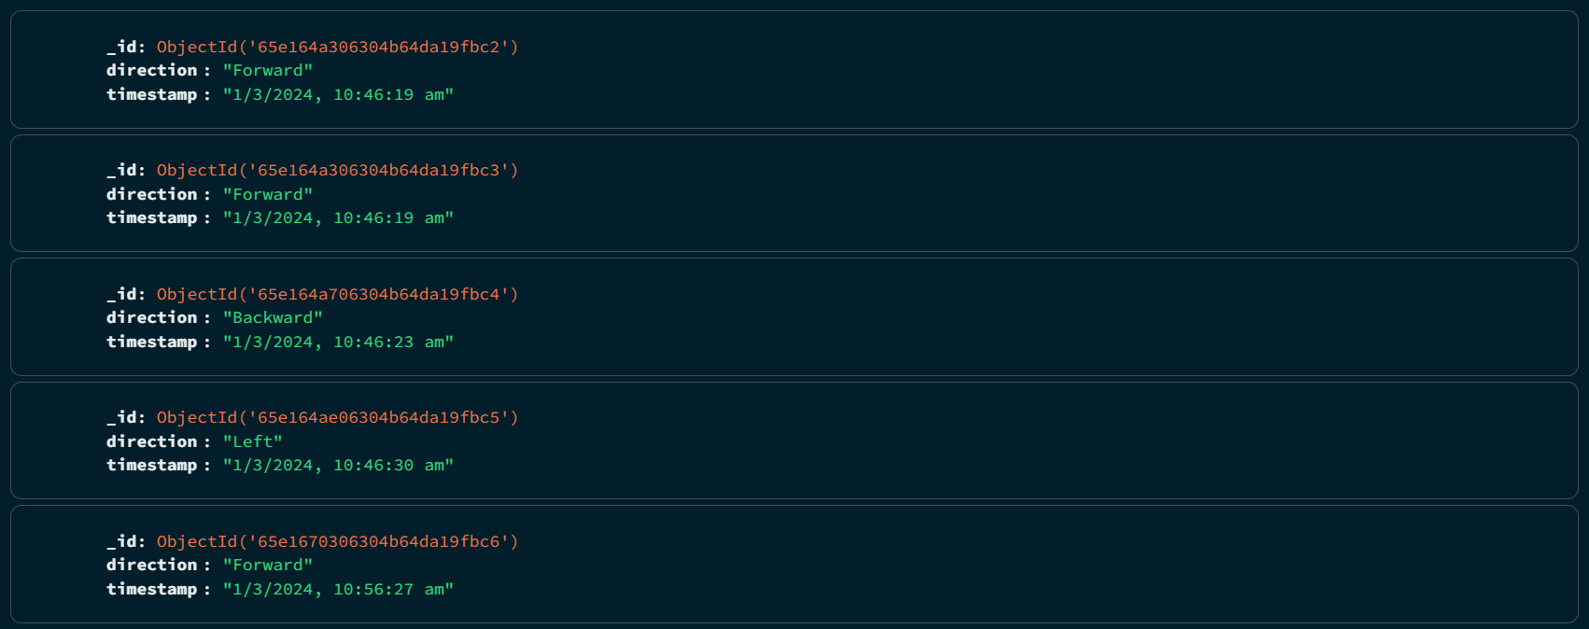

**CODE OVERVIEW:**

The main code which is deployed on the Raspberry Pi is essentially coded in python.

**1)Libraries**

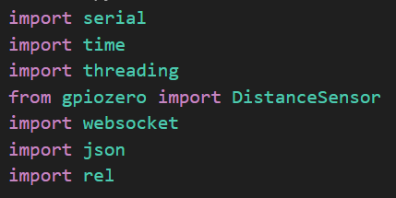

**serial**: Provides functionality for serial communication with devices.

**time**: Offers various functions for working with dates, times, and durations.

**threading**: Enables the creation and management of threads for concurrent execution.

**gpiozero**: Simplifies working with GPIO (General Purpose Input/Output) pins on electronic devices.

**webSocket**: Implements WebSocket communication for real-time data exchange between clients and servers.

**json**: Facilitates the encoding and decoding of data in JSON (JavaScript Object Notation) format.

**rel**: (also known as requests-el): A library built on top of Requests that simplifies making asynchronous HTTP requests.

**2)Motor commands and initialization**

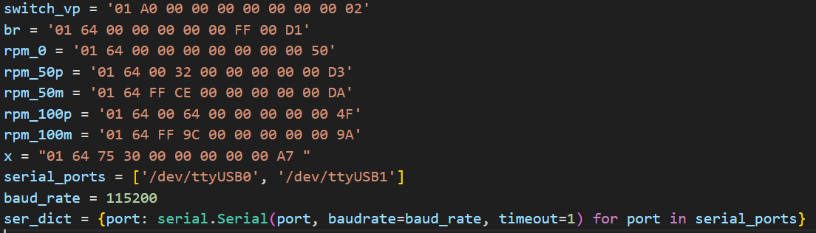

In this part we have initialized all the motor commands(**DDSM 115 Motor**) required for the various commands(forward,backward,etcetera). The serial ports which are controlling the two channels(3 motors on each channel) are also initialized.

**3)Defined Functions**

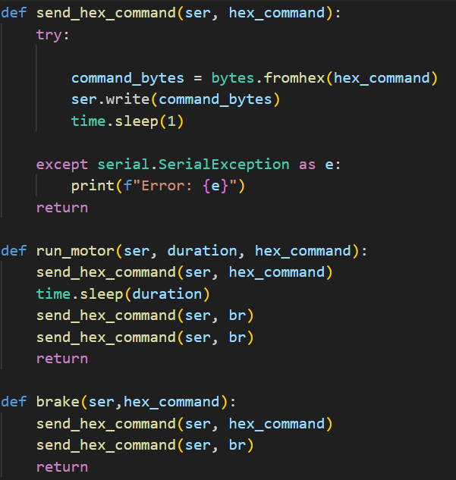

The **send_hex_command()** function converts the hexadecimal motor code to binary code.The **run_motor()** function sends the converted binary code to the motor.

The **brake()** function particularly sends a brake command to the car.

**4)Function for sending commands.**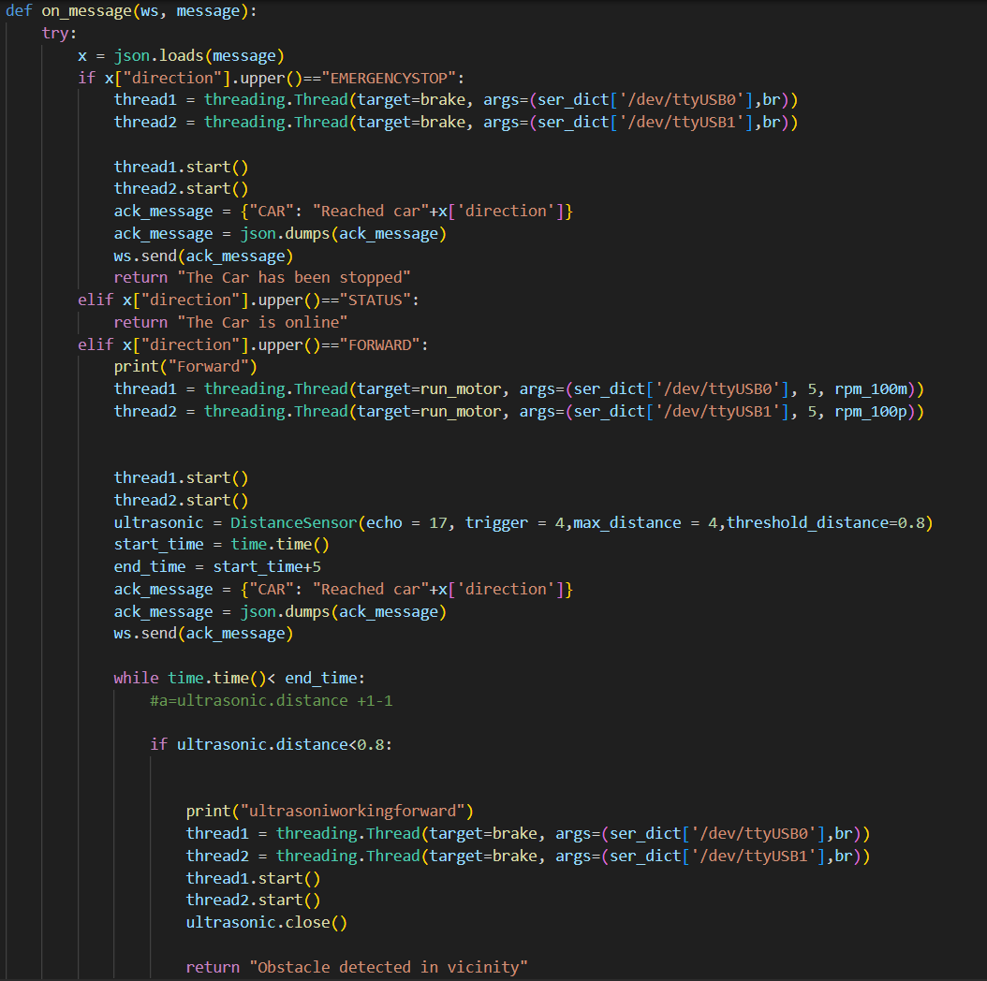

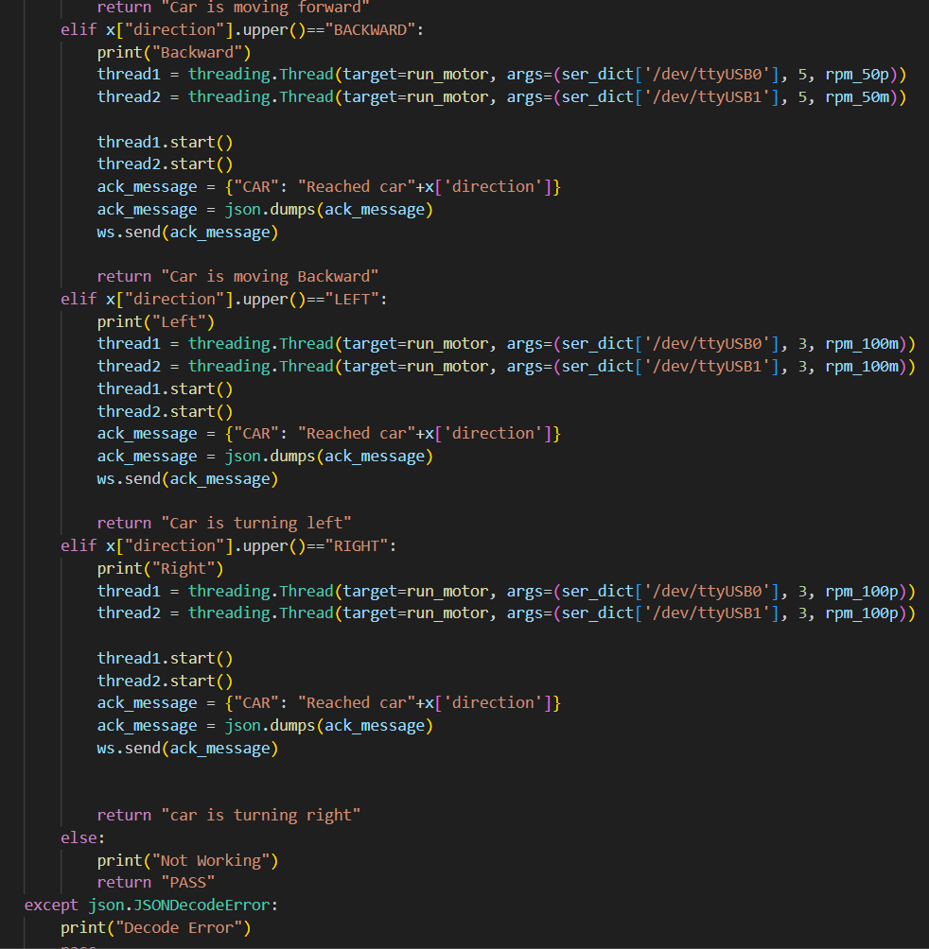

This function receives the command from the websocket, and executes it accordingly. We have Emergency Stop,Forward,Reverse,Left and Right commands which run the command asynchronously with the help of threading which executes both the motor channels simultaneously.

**5) Error handling and main function()**

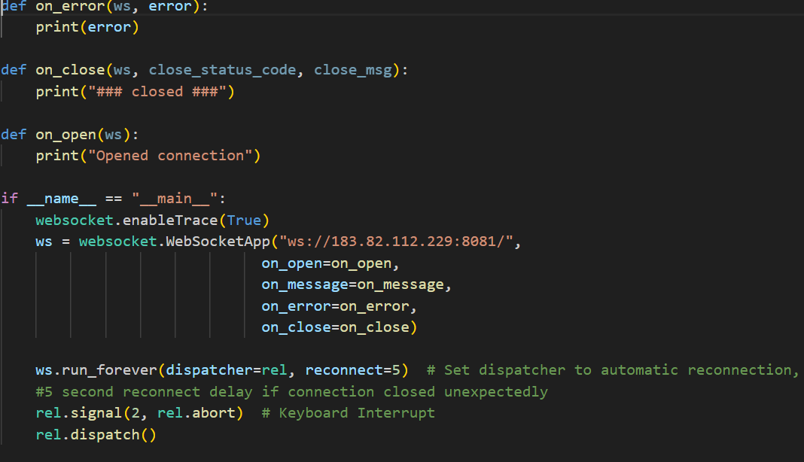

This part has basic error handlings and the main function, which essentially sets up the websocket connection.

**REFERENCE:**

1)Waveshare DDSM115: <https://www.waveshare.com/wiki/DDSM115>

2)AWS: <https://docs.aws.amazon.com/>

3)Alexa Development Console: <https://developer.amazon.com/en-US/docs/alexa/documentation-home.html>

4)MongoDB: <https://www.mongodb.com/docs/>

5)Raspberry Pi: <https://www.raspberrypi.com/documentation/computers/raspberry-pi.html>

6)ViteJS: <https://devdocs.io/vite/>

7)SocketXP: <https://www.socketxp.com/>

8)ExpressJS: <https://expressjs.com/en/5x/api.html>

9)YD Lidar : <https://github.com/YDLIDAR/YDLidar-SDK>

10)Websocket:<https://github.com/Pithikos/python-websocket-server>

Other Projects Referred :

11)<https://how2electronics.com/wireless-voice-controlled-robot-car-using-arduino/>

12)<https://www.instructables.com/VBot-Powered-by-Alexa/>